Chapter 4, Problem 36.

Solve for the current i in the circuit of Fig. 4.103 using Thevenin’s theorem. (Hint: Find the Thevenin equivalent as seen by the 12-Ω resistor.)

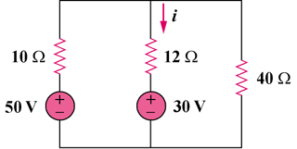

Figure 4.103
For Prob. 4.36.

